**Michigan**

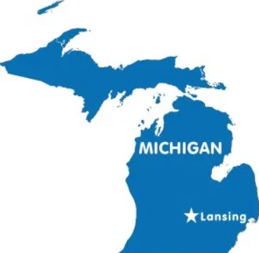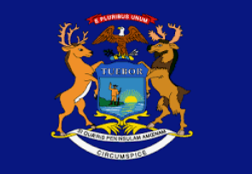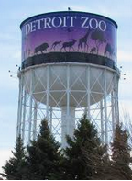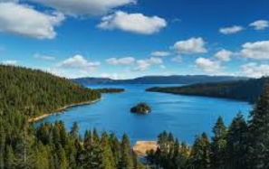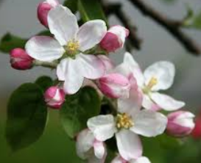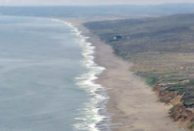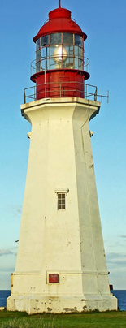

**Michigan’s state bird is a Robin.**

**The Detroit Zoo was the first zoo to have cage less exhibits.**

**Michigan has 11,000 inland lakes.**

**Michigan’s state flower is the Apple Blossom.**

**Michigan has the longest freshwater shoreline in the world.**

**Michigan has 116 lighthouses.**

**Detroit is known as the car capital of the world.**

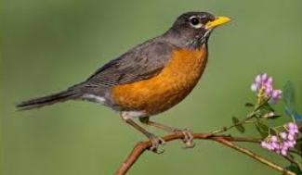

* **Michigan is part of the Mid-West Region.**
* **Michigan is made up of 9.987 million people.**
* **Michigan was named the 26th state on January 26, 1837.**



Landforms of Michigan

* Major Rivers
  + Au Sable
  + The Muskegon
* Major Lakes
  + Huron
  + Ontario
  + Michigan
  + Erie
  + Superior
* Mountains
  + The Porcupine Mountains
* Sand Dune
  + Sleepy Bear Dunes
* Waterfalls
  + Tahquamenon Falls
* Islands
  + Mackinac

Industries

* Manufacturing
  + General Motors
  + Chrysler
  + Ford
  + Better Made
  + Vernors
* Tourism
  + Detroit Institute of Arts
  + Henry Ford Museum
  + Sleeping Bear Dunes
  + Soo Locks
  + Mackinac Island
  + Tahquamenon Falls

Reasons to visit Michigan……

1. You should visit Michigan because you can visit our natural made waterfalls known as Tahquamenon Falls.

2. You should visit Michigan because you can see the Model T Ford car at the Henry Ford Museum.

3. You should visit Michigan because you can pick fresh cherries at the Cherry Festival in Traverse City.

4. You should visit Michigan because you can enjoy all of our freshwater lakes for swimming, boating, etc.

5. You should visit Michigan because you can take a ferry boat to Mackinac Island.

**Michigan gets all four seasons (winter, spring, summer, and fall).**